{0><}100{>THANOS PAPAKONSTANTINOU<0}
{0><}0{>Director and actor.<0} {0><}0{>He has directed:<0} {0><}0{>Hope of Homeland by George Kouroupos (conducted by Miltos Logiadis, Athens Concert Hall, 2021), Argos Sidiros by Andys Skordis (conducted by Zoi Tsokanou, Cyprus International Festival, Nicosia, 2021), Juditha Triumphans by Antonio Vivaldi (conducted by Markellos Chrysikopoulos, Greek National Opera, 2021), The Free Besieged by Dionysios Solomos (National Theatre of Greece, 2021), The Apocalypse (Onassis Stegi, 2019), The Haunted by Dimitris Maramis (conducted by Dimitris Maramis, Athens Concert Hall, 2019), Electra by Sophocles (National Theatre of Greece, Epidaurus, 2018), L'Orfeo by Claudio Monteverdi (conducted by Markellos Chrysikopoulos, Athens Concert Hall, 2018), Colossus (based on Agamemnon by Aeschylus, MCF, 2017), Red Shift by Giannis Mavritsakis (Athens Festival, 2014 and repeated in 2015), Macbeth by Shakespeare (Apo Mihanis Theatre, 2015), Pedestal (based on Aeschylus’ Libation Bearers, MCF, 2013), Venison (based on Aeschylus’ Eumenides, MCF, 2012), Hamlet, Prince of Denmark by Shakespeare (Michael Cacoyannis Foundation - MCF, 2011).<0}

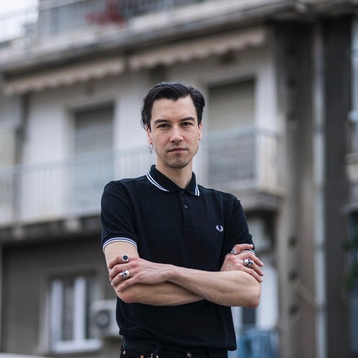
KONSTANTINA ANGELOPOULOU
Graduate of the Athens Conservatoire School of Drama. Graduate of the Nees Morfes theatre workshop, the Theatro Domatiou studio and the M. Yemendzaki studio.
She has appeared as an actor/performer in the following productions: Ivanov directed by A. Brouskou, Kykladon Street Theatre. The Exterminating Angel directed by A. Brouskou, Athens and Epidaurus Festival. Hedda Gabler directed by A. Brouskou, Bageion. 4.48 Psychosis directed by A. Brouskou, BIOS, Thessaloniki Festival, 49th Dimitria Festival, State Regional Theatre of Patras, Thiseion Theatre. Epitaph for Democracy Theatro Domatiou. documenta 14 building in Eleftherias Park. Breath: A route in an active soundscape (in the Hypnos project). Sound walk and sound installation at the First Cemetery, Athens curated by D. Karmarotos. Lighting of the Olympic Flame Choreographer A. Ignatiou, Panathenaic Stadium. Magda Goebbels directed by A. Brouskou, National Theatre of Greece. The bitter tears of Petra von Kant directed by A. Brouskou, National Theatre of Greece. Bacchae directed by A. Brouskou, Athens and Epidaurus Festival. The Throne of Atreus directed by A. Retsos, Athens Festival. Love in tatters directed by A. Brouskou, The Old Olive Oil Factory, Elefsina. The birds choreographed by A. Ignatiou, National Museum of Contemporary Art. Waiting... something about hunger directed by A. Brouskou, BIOS. Stories of the Rocks directed by M. Bekri, Nees Morfes studio. Laughing Wild directed by T. Tzamaria, Mylos.
She has worked as a directing assistant on the following productions: Apocalypse directed by T. Papakonstantinou, Onassis Stegi. Fat Men in Skirts directed by G. Paraskevopoulou, Nees Morfes studio. A Streetcar Named Desire directed by A. Brouskou, Pallas Theatre. Agamemnon directed by A. Brouskou, Athens and Epidaurus Festival. Miss Margarida's Way directed by A. Brouskou, Aplo Theatro. Reality directed by A. Brouskou, Pallas Theatre. Jackie directed by A. Brouskou, Apo Mihanis Theatre. The Throne of Atreus directed by A. Retsos, Athens Festival.

CANDY KARRA
Candy Karra is a dancer, performer, facilitator, and educator. She has graduated from the “Niki Kontaxaki” Higher Professional School of Dance and holds a BA in Pedagogical Studies from the Kapodistriako National University of Athens, both with distinction. In 2012 she was invited to participate in Ultima Vez’s first monthly and intensive research program on theater and dance in Brussels and in 2016, in the EUROPOLY - masterclass for young artists at the Kammerspiele in Munich. She is currently doing her MFA in MET - Athens School of Fine Arts.
Alternating her working roles, over the past ten years she creates and performs in collaboration with various choreographers and dance companies, participating in festivals in Greece, Cyprus, Germany, Spain and New York (Athens & Epidaurus Festival, Kalamata International Dance Festival, Dancing Athens Festival of Onassis Cultural Center, Metamorphosis and Nostos Summer Festival of Stavros Niarchos Foundation, Arc For Dance Festival, In Progress festival at KINITIRAS residency center, Akropoditi DanceFest, Athens Video Dance Project festival, Kypria International Festival, Folkwang Physical Theater Festival at Essen – Germany, pad - Performance Art Depot at Mainz – Germany, MASDANZA at Mas Palomas and Tenerife - Canary Islands, Figueres es Mou – Spain, Battery Dance Festival - New York and others.). She regularly teaches dance and facilitates educational programs based on improvisation and a dialog between different art forms in collaboration with the Onassis Stegi, Cavafy Archive, and the cross-cultural organization Polyphonica, among others, while she is part-time faculty of Deree - The American College of Greece since 2016. In 2020 she co-choreographed and performed the piece “manoeuvre_” which premiered in the 7th New Choreographers Festival of Onassis Stegi and was afterwards presented at in Miniature of Akropoditi Dance & Performing Arts Centre, the accessible Synama Festival #1 of Liminal Access Force and MPArt, 8th Mill of Performing Arts with the support of Onassis Stegi. She has worked as a choreographer for theater performances of the directors Thanos Papakonstantinou, Kostas Papakonstantinou and Katerina Giannopoulou.

