PRESS RELEASE – for immediate release – 06/09/2019
A Season Dedicated to Youth Theatre: Young Europe III Opened Yesterday

The ETC’s artistic collaboration project Young Europe III was kicked off yesterday with the premiere of Rage, a classroom play created by Deutsches Theater Berlin. A total of nine new productions with and for young people will be premiered this season across the continent.
Young Europe III focuses on theatre as a place of identification for young people in Europe. Over two years, nine ETC Member Theatres collaborated to develop new theatre texts on the topic of identity and integration, which will expand European multilingual drama for young audiences.

Democrisis
A gameplay developed in cooperation between Theatre Magdeburg (Germany), Staatstheater Braunschweig (Germany) and the National Theatre "Marin Sorescu" in Craiova (Romania). The immersive gameplay Democrisis is based on interviews with 14 to 20-year-old people from Braunschweig, Magdeburg and Craiova and asks the question: What would we lose if we put our democracy at risk?
- Democrisis, Theater Magdeburg/Germany - 8 November 2019 / More...
- Democrisis, Staatstheater Braunschweig/Germany - 21 November 2019 / More...
- Democrisis, "Marin Sorescu" National Theatre of Craiova/Romania - 17 November 2019 / More...

Plan(et) B / Before Tomorrow / Strange Things
As part of Young Europe III, Pesti Magyar Szinház in Budapest (Hungary) collaborated with the theatres Badisches Staatstheater in Karlsruhe (Germany) and Slovak National Drama Theatre in Bratislava (Slovakia). Together, they researched the views of young people today across their three countries. They have each created a performance inspired by young people’s ideas of identity and their visions of the future.
- Planet B, Badisches Staatstheater Karlsruhe/Germany – 02 October 2019 / More…
- Before Tomorrow, Pesti Magyar Szinház/Hungary – 05 October 2019 / More…
- Strange Things, Slovak National Drama Theatre/Slovakia – 10 October 2019 / More…

Age of Rage / Rage
The theatres Deutsches Theater in Berlin (Germany), Weöres Sándor Szinház (Hungary) and De Toneelmakerij in Amsterdam (Netherlands) collaborated to find out what was occupying the minds of the young generation today. What emerged was a clear theme of democracy – its meaning and implication both now and in the future. Each theatre created a new production based on their combined research.
- Rage, Deutsches Theater Berlin/Germany – 05 September 2019 / More…
- Age of Rage, De Toneelmakerij/Netherlands – 28 September 2019 / More…
- Weöres Sándor Szinház/Hungary – 18 December 2019

All nine theatres will also join together for the Young Europe Festival in Graz (Austria) to showcase their productions as one. The Young Europe Festival will take place from 09 to 11 June 2020, just before the opening of the ETC International Theatre Conference.
More information about Young Europe III can be found here: www.youngeurope3.eu

About the European Theatre Convention (ETC)
An artistic platform for creation, innovation and collaboration
As the largest network of public theatres in Europe, the ETC has more than 40 European Member Theatres from over 20 countries, reflecting the diversity of Europe’s vibrant cultural sector. Founded in 1988, the ETC promotes European theatre as a vital platform for dialogue, democracy and interaction that responds to, reflects and engages with today’s diverse audiences and changing societies.
More: www.europeantheatre.eu

Press Contact
Joséphine Dusol communication@europeantheatre.eu – +49 30 28441 402
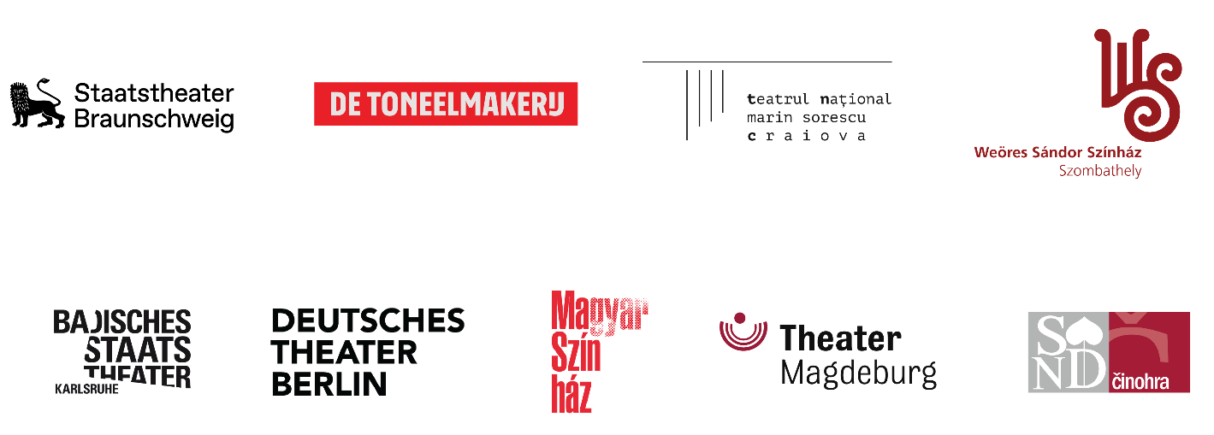

Young Europe III is developed in cooperation with Allianz Kulturstiftung and is co-funded by the Creative Europe Programme of the European Union.

